MINI PROJECT

NOISE DETECTOR USING AUTOMATIC RECORDED SYSTEM

# Contents

* **Introduction**
* **Review of Literature**
* **Components**
* **Block Diagram/Circuit Diagram**
* **Flowchart**
* **Connections**
* **Simulation Result**
* **Working**
* **Conclusion**

Abstract:

The world of the internet of things is limitless and comes with a lot of real-world applications. It’s been a few years since the word IoT became familiar to the world of technology. Since then, there have been many innovative ideas backed with the power of this ground-breaking technology. From day to application high level once there are IoT devices everywhere. Today we are going to see about a Noise detection system that uses IoT. Noise can be a big problem for many of us in a variety of scenarios. From being one of the less known and considered environment pollutants to a big distraction during office hour’s noise is a hidden evil. We all have come across some one who talk loudly which stops us from concentrating on what we were doing. From offices to libraries and classroom noise has always been a problem. So,with IoT, we are going to find a solution to this noise problem. A noise detector with the capability to record audio is the idea of the day. In this way, we can find out who made the noise and punish them or let them hear their high pitch noise so they realize what they were doing wrong the whole time

Introduction:

A custom-made app is developed that will start recording when the sound goes above the desired level. The Arduino Nano board Is used to which a Bluetooth receiver ,a sound senso, and a buzzer are connected. The Bluetooth is connected with the smart phone which has the app installed. Once the sound crosses the set value it will start the recording on the smart phone. Once the level of noise comes down the recording is automatically stopped.

Literature Survey:

As the noise pollution is increasing day by day there is adverse effect of it on us. Increasing noise creates a lot of disturbance at various places like library, reading halls. Hence to reduce this problem we have created this notice detector by which we can set a threshold value and it will automatically record and the buzzer will start creating sound.

Components:

1. Smartphone
2. Bluetooth HC05 Module
3. Arduino Nano
4. Sound Sensor
5. Buzzer
6. Wires

Block Diagram/Circuit Diagram:

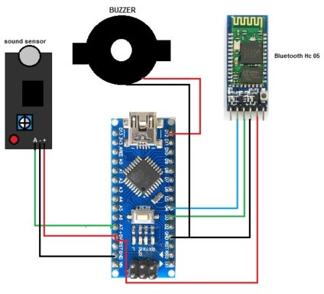

Flowchart

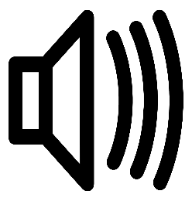

[This Photo](https://commons.wikimedia.org/wiki/File:Icon_sound_loudspeaker.svg) by Unknown Author is licensed under [CC BY-SA](https://creativecommons.org/licenses/by-sa/3.0/)

Connections:

|  |  |
| --- | --- |
| **Arduino Nano** | **Components** |
| Pin A7 | Sound Sensor Out |
| 5v | VCC Bluetooth & Sound sensor |
| GND | GND Bluetooth & Sound senor |
| D4 | RX |
| D3 | TX |
| D12 | Buzzer VCC |
| GND | Buzzer GND |

Software used:

The Proteus is an electronic circuit design software which includes a schematic capture, simulation and PCB (Printed Circuit Board) Layout modules. Proteus is ahead in simulating the circuits containing the micro controllers where we can simulate the circuit by uploading the hex code to the Micro-controller whereas Mutism can't do this.

Working and Simulation:

Now, we have to power the Arduino and connect the Bluetooth with Android app. After successful connection, we can test it by making loud noise. When sound level crosses the threshold value, the Noise Detector device will buzz to notify about it and at the same time the app will start recording the sound and it will go on recording until the noise level comes down below the threshold level.

We can adjust the threshold noise level in android app code which we developed using MIT app Inventor.

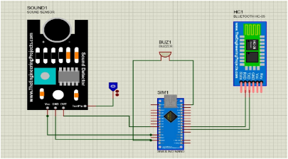No Sound detected

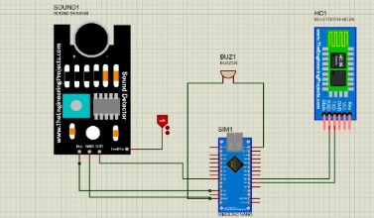Sound Detected

Arduino Code:

// variable declaration

int senpin=A5;

int buzzer=12;

long val=0;

long average=0;

int threshold=40;

String answ;

#include<SoftwareSerial.h>

SoftwareSerial mySerial(3, 4);

void setup(){

pinMode(senpin,INPUT);

pinMode(buzzer,OUTPUT);

Serial.begin(9600);// to start serial communication b/w nano and Hc-05

mySerial.begin(9600);

}

//Reading strings from bluetooh

void loop(){

if(mySerial.available()!=0){

answ=Serial.readStringUntil('\n');

threshold=answ.toInt();

}

sensor();

}

// To calculate noise level

void sensor(){

for(int i=0; i <160 ; i++)

{average = average +analogRead(senpin);

}

val = average/160;

average=0;

delay(10);

Serial.print(val);

Serial.println(threshold);

if(val>=threshold){

mySerial.println(val);

digitalWrite(buzzer,HIGH);

delay(150);

digitalWrite(buzzer,LOW);

delay(150);

digitalWrite(buzzer,HIGH);

delay(200);

digitalWrite(buzzer,LOW);

delay(900);

}

}

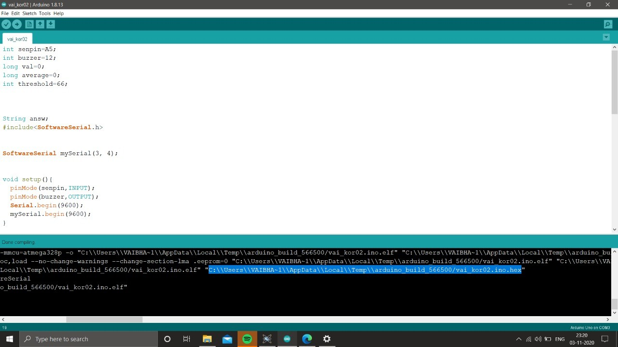

MIT App Layout:

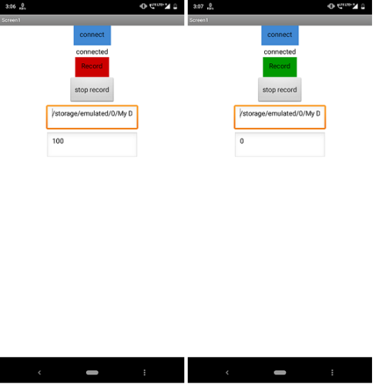

**Code Block:**

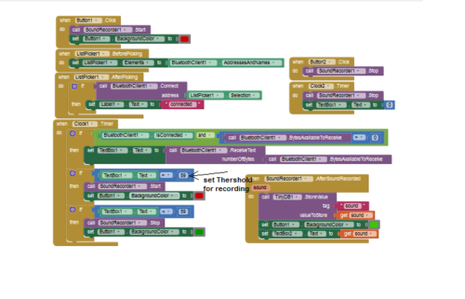

**Advantage:**

1. To maintain Noise level in silent area.
2. When noise increases beyond 40dB sound will get recorded.

**Disadvantage:**

Conclusion:

1. To overcome this issue, this Noise Detector System can be used in library, office and classroom environments to identify noisy people so that necessary action can be taken against them.
2. We can implement this project on global scale as it is need to keep silence in silent zones such as hospital, libraries. So it has good future scope and it’s cheaper